REQUEST PAGE / CONTACT US

http://localhost:3000/contact

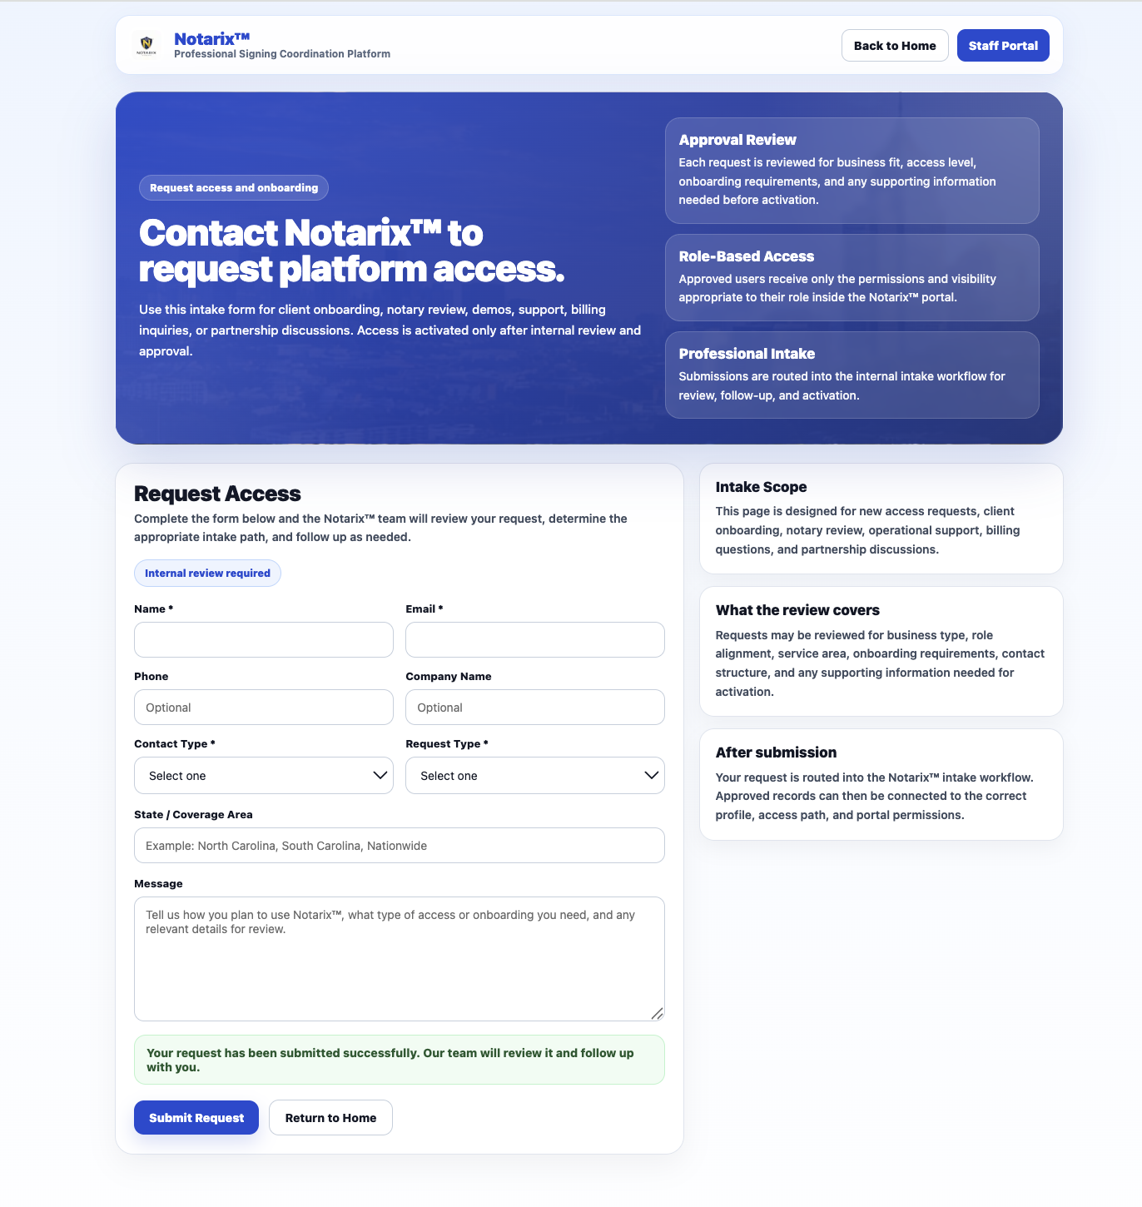

app/contact/page.tsx

*The contact us page and the home page are linked by the href=”/contact”

"use client";

import Image from "next/image";
import { useMemo, useState } from "react";

type FormState = {
name: string;
email: string;
phone: string;
company: string;
contactType: string;
requestType: string;
coverageArea: string;
message: string;
};

const INITIAL_FORM: FormState = {
name: "",
email: "",
phone: "",
company: "",
contactType: "",
requestType: "",
coverageArea: "",
message: "",
};

export default function ContactPage() {
const [form, setForm] = useState<FormState>(INITIAL_FORM);
const [loading, setLoading] = useState(false);
const [result, setResult] = useState<{
ok: boolean;
message: string;
} | null>(null);

const messagePlaceholder = useMemo(() => {
switch (form.requestType) {
case "Request Platform Access":
return "Tell us about your organization, the type of access you need, and any onboarding details our team should review.";
case "Request Notary Review":
return "Tell us about your signing experience, service area, credentials, and how you would like to work with Notarix™.";
case "Request Demo":
return "Tell us about your current workflow, who would use the platform, and what you want to review in a Notarix™ demo.";
case "Support Request":
return "Describe the issue, what page or workflow you were using, and any details that will help us resolve it quickly.";
case "Partnership Inquiry":
return "Tell us about your business, your services, and the type of partnership or commercial discussion you want to have.";
case "Billing / Accounting":
return "Provide the billing, payment, or accounting details our team should review.";
case "Integration / Technical Inquiry":
return "Describe your current systems and the integration or technical discussion you would like to have with Notarix™.";
default:
return "Tell us how you plan to use Notarix™, what type of access or onboarding you need, and any relevant details for review.";
}
}, [form.requestType]);

function handleChange(
e: React.ChangeEvent<HTMLInputElement | HTMLTextAreaElement | HTMLSelectElement>
) {
const { name, value } = e.target;
setForm((prev) => ({ ...prev, [name]: value }));
}

async function handleSubmit(e: React.FormEvent<HTMLFormElement>) {
e.preventDefault();
setLoading(true);
setResult(null);

if (!form.name || !form.email || !form.contactType || !form.requestType) {
setResult({
ok: false,
message:
"Please complete Name, Email, Contact Type, and Request Type before submitting.",
});
setLoading(false);
return;
}

try {
const response = await fetch("/api/intake", {
method: "POST",
headers: {
"Content-Type": "application/json",
},
body: JSON.stringify(form),
});

const data = await response.json();

if (!response.ok) {
setResult({
ok: false,
message: data?.error || "Something went wrong. Please try again.",
});
setLoading(false);
return;
}

setResult({
ok: true,
message:
"Your request has been submitted successfully. Our team will review it and follow up with you.",
});

setForm(INITIAL_FORM);
} catch {
setResult({
ok: false,
message: "Unable to submit your request right now. Please try again.",
});
} finally {
setLoading(false);
}
}

return (
<main
style={{
minHeight: "100vh",
background:
"linear-gradient(180deg, #EFF6FF 0%, #F8FBFF 42%, #FFFFFF 100%)",
fontFamily:
'ui-sans-serif, system-ui, -apple-system, BlinkMacSystemFont, "Segoe UI", sans-serif',
color: "#0F172A",
}}
>
<section
style={{
maxWidth: 1180,
margin: "0 auto",
padding: "16px 20px 10px",
}}
>
<div
style={{
background: "rgba(255,255,255,0.92)",
border: "1px solid #DBEAFE",
borderRadius: 18,
padding: "14px 16px",
display: "flex",
alignItems: "center",
justifyContent: "space-between",
gap: 12,
flexWrap: "wrap",
boxShadow: "0 10px 30px rgba(30, 64, 175, 0.08)",
backdropFilter: "blur(10px)",
WebkitBackdropFilter: "blur(10px)",
}}
>
<div style={{ display: "flex", alignItems: "center", gap: 12 }}>
<Image
src="/notarix-logo.png"
alt="Notarix™"
width={42}
height={42}
style={{
width: 42,
height: 42,
objectFit: "contain",
background: "#FFFFFF",
borderRadius: 10,
padding: 3,
}}
/>
<div>
<div
style={{
fontWeight: 950,
fontSize: 20,
lineHeight: 1.05,
letterSpacing: -0.2,
color: "#1D4ED8",
}}
>
Notarix™
</div>
<div
style={{
fontSize: 12,
color: "#64748B",
fontWeight: 700,
}}
>
Professional Signing Coordination Platform
</div>
</div>
</div>

<div style={{ display: "flex", gap: 10, flexWrap: "wrap" }}>
<a href="/" style={navButtonSecondary}>
Back to Home
</a>
<a href="/admin" style={navButtonPrimary}>
Staff Portal
</a>
</div>
</div>
</section>

<section
style={{
maxWidth: 1180,
margin: "0 auto",
padding: "10px 20px 14px",
}}
>
<div
style={{
position: "relative",
overflow: "hidden",
borderRadius: 28,
minHeight: 310,
backgroundImage:
"linear-gradient(135deg, rgba(29, 78, 216, 0.88) 0%, rgba(30, 64, 175, 0.92) 48%, rgba(30, 58, 138, 0.94) 100%), url('/city-hero.jpg')",
backgroundSize: "cover",
backgroundPosition: "center",
backgroundRepeat: "no-repeat",
color: "#FFFFFF",
boxShadow: "0 24px 60px rgba(30, 64, 175, 0.18)",
border: "1px solid rgba(255,255,255,0.12)",
}}
>
<div
style={{
position: "absolute",
inset: 0,
background:
"radial-gradient(circle at top right, rgba(255,255,255,0.16), transparent 30%), radial-gradient(circle at bottom left, rgba(255,255,255,0.10), transparent 28%)",
pointerEvents: "none",
}}
/>

<div
style={{
position: "relative",
zIndex: 1,
display: "grid",
gridTemplateColumns: "1.15fr 0.85fr",
gap: 22,
alignItems: "stretch",
minHeight: 310,
padding: "30px 28px",
}}
>
<div style={{ display: "flex", flexDirection: "column", justifyContent: "center" }}>
<div
style={{
display: "inline-flex",
alignItems: "center",
width: "fit-content",
gap: 8,
background: "rgba(255,255,255,0.14)",
border: "1px solid rgba(255,255,255,0.18)",
borderRadius: 999,
padding: "7px 12px",
fontSize: 12,
fontWeight: 900,
marginBottom: 16,
letterSpacing: 0.1,
}}
>
Request access and onboarding
</div>

<h1
style={{
margin: 0,
fontSize: 44,
lineHeight: 0.98,
fontWeight: 950,
letterSpacing: -1.2,
maxWidth: 720,
textWrap: "balance",
}}
>
Contact Notarix™ to request platform access.
</h1>

<p
style={{
marginTop: 16,
marginBottom: 0,
maxWidth: 720,
fontSize: 15,
lineHeight: 1.65,
color: "rgba(255,255,255,0.96)",
fontWeight: 500,
}}
>
Use this intake form for client onboarding, notary review, demos,
support, billing inquiries, or partnership discussions. Access is
activated only after internal review and approval.
</p>
</div>

<div
style={{
display: "grid",
gap: 12,
alignContent: "center",
}}
>
<HeroInfoCard
title="Approval Review"
text="Each request is reviewed for business fit, access level, onboarding requirements, and any supporting information needed before activation."
/>
<HeroInfoCard
title="Role-Based Access"
text="Approved users receive only the permissions and visibility appropriate to their role inside the Notarix™ portal."
/>
<HeroInfoCard
title="Professional Intake"
text="Submissions are routed into the internal intake workflow for review, follow-up, and activation."
/>
</div>
</div>
</div>
</section>

<section
style={{
maxWidth: 1180,
margin: "0 auto",
padding: "8px 20px 28px",
}}
>
<div
style={{
display: "grid",
gridTemplateColumns: "1.22fr 0.78fr",
gap: 18,
alignItems: "start",
}}
>
<div
style={{
background: "rgba(255,255,255,0.96)",
border: "1px solid #E2E8F0",
borderRadius: 22,
padding: "22px 22px",
boxShadow: "0 14px 34px rgba(15, 23, 42, 0.05)",
}}
>
<div
style={{
display: "flex",
alignItems: "flex-start",
justifyContent: "space-between",
gap: 16,
flexWrap: "wrap",
marginBottom: 18,
}}
>
<div>
<div
style={{
fontSize: 26,
fontWeight: 950,
color: "#0F172A",
lineHeight: 1.05,
letterSpacing: -0.5,
}}
>
Request Access
</div>
<div
style={{
marginTop: 6,
fontSize: 14,
lineHeight: 1.55,
color: "#475569",
fontWeight: 600,
maxWidth: 700,
}}
>
Complete the form below and the Notarix™ team will review your request,
determine the appropriate intake path, and follow up as needed.
</div>
</div>

<div
style={{
display: "inline-flex",
alignItems: "center",
gap: 8,
border: "1px solid #BFDBFE",
background: "#EFF6FF",
color: "#1D4ED8",
borderRadius: 999,
padding: "8px 12px",
fontSize: 12,
fontWeight: 900,
whiteSpace: "nowrap",
}}
>
Internal review required
</div>
</div>

<form onSubmit={handleSubmit} style={{ display: "grid", gap: 16 }}>
<div
style={{
display: "grid",
gridTemplateColumns: "repeat(2, minmax(0, 1fr))",
gap: 14,
}}
>
<Field label="Name *">
<input
name="name"
type="text"
value={form.name}
onChange={handleChange}
required
style={inputStyle}
/>
</Field>

<Field label="Email *">
<input
name="email"
type="email"
value={form.email}
onChange={handleChange}
required
style={inputStyle}
/>
</Field>

<Field label="Phone">
<input
name="phone"
type="text"
value={form.phone}
onChange={handleChange}
placeholder="Optional"
style={inputStyle}
/>
</Field>

<Field label="Company Name">
<input
name="company"
type="text"
value={form.company}
onChange={handleChange}
placeholder="Optional"
style={inputStyle}
/>
</Field>

<Field label="Contact Type *">
<select
name="contactType"
value={form.contactType}
onChange={handleChange}
required
style={inputStyle}
>
<option value="">Select one</option>
<option value="Client">Client</option>
<option value="Notary">Notary</option>
<option value="General">General</option>
</select>
</Field>

<Field label="Request Type *">
<select
name="requestType"
value={form.requestType}
onChange={handleChange}
required
style={inputStyle}
>
<option value="">Select one</option>
<option value="Request Platform Access">
Request Platform Access
</option>
<option value="Request Notary Review">
Request Notary Review
</option>
<option value="Request Demo">Request Demo</option>
<option value="Support Request">Support Request</option>
<option value="Billing / Accounting">Billing / Accounting</option>
<option value="Partnership Inquiry">Partnership Inquiry</option>
<option value="Integration / Technical Inquiry">
Integration / Technical Inquiry
</option>
<option value="Other">Other</option>
</select>
</Field>
</div>

<Field label="State / Coverage Area">
<input
name="coverageArea"
type="text"
value={form.coverageArea}
onChange={handleChange}
placeholder="Example: North Carolina, South Carolina, Nationwide"
style={inputStyle}
/>
</Field>

<Field label="Message">
<textarea
name="message"
rows={6}
value={form.message}
onChange={handleChange}
placeholder={messagePlaceholder}
style={{ ...inputStyle, minHeight: 150, resize: "vertical" }}
/>
</Field>

{result ? (
<div
style={{
border: result.ok ? "1px solid #BBF7D0" : "1px solid #FECACA",
background: result.ok ? "#F0FDF4" : "#FEF2F2",
color: result.ok ? "#166534" : "#B91C1C",
borderRadius: 14,
padding: "12px 14px",
fontSize: 14,
fontWeight: 800,
}}
>
{result.message}
</div>
) : null}

<div
style={{
display: "flex",
alignItems: "center",
gap: 12,
flexWrap: "wrap",
paddingTop: 2,
}}
>
<button
type="submit"
disabled={loading}
style={{
border: 0,
borderRadius: 12,
padding: "12px 18px",
fontWeight: 900,
fontSize: 14,
background: loading ? "#94A3B8" : "#1D4ED8",
color: "#FFFFFF",
cursor: loading ? "not-allowed" : "pointer",
boxShadow: "0 10px 22px rgba(29, 78, 216, 0.18)",
}}
>
{loading ? "Submitting Request..." : "Submit Request"}
</button>

<a href="/" style={secondaryActionButton}>
Return to Home
</a>
</div>
</form>
</div>

<div style={{ display: "grid", gap: 14 }}>
<SidePanel
title="Intake Scope"
text="This page is designed for new access requests, client onboarding, notary review, operational support, billing questions, and partnership discussions."
/>
<SidePanel
title="What the review covers"
text="Requests may be reviewed for business type, role alignment, service area, onboarding requirements, contact structure, and any supporting information needed for activation."
/>
<SidePanel
title="After submission"
text="Your request is routed into the Notarix™ intake workflow. Approved records can then be connected to the correct profile, access path, and portal permissions."
/>
</div>
</div>
</section>
</main>
);
}

function Field({
label,
children,
}: {
label: string;
children: React.ReactNode;
}) {
return (
<label style={{ display: "grid", gap: 8 }}>
<span
style={{
fontSize: 13,
fontWeight: 800,
color: "#0F172A",
}}
>
{label}
</span>
{children}
</label>
);
}

function HeroInfoCard({
title,
text,
}: {
title: string;
text: string;
}) {
return (
<div
style={{
background: "rgba(255,255,255,0.12)",
border: "1px solid rgba(255,255,255,0.16)",
borderRadius: 18,
padding: "16px 16px",
backdropFilter: "blur(4px)",
WebkitBackdropFilter: "blur(4px)",
}}
>
<div
style={{
fontSize: 17,
fontWeight: 900,
lineHeight: 1.2,
marginBottom: 6,
}}
>
{title}
</div>
<div
style={{
fontSize: 14,
lineHeight: 1.6,
color: "rgba(255,255,255,0.94)",
fontWeight: 500,
}}
>
{text}
</div>
</div>
);
}

function SidePanel({
title,
text,
}: {
title: string;
text: string;
}) {
return (
<div
style={{
background: "rgba(255,255,255,0.96)",
border: "1px solid #E2E8F0",
borderRadius: 18,
padding: "18px 18px",
boxShadow: "0 10px 24px rgba(15, 23, 42, 0.05)",
}}
>
<div
style={{
fontSize: 17,
fontWeight: 900,
color: "#0F172A",
marginBottom: 8,
lineHeight: 1.2,
}}
>
{title}
</div>
<div
style={{
fontSize: 14,
lineHeight: 1.62,
fontWeight: 600,
color: "#475569",
}}
>
{text}
</div>
</div>
);
}

const inputStyle: React.CSSProperties = {
width: "100%",
border: "1px solid #CBD5E1",
borderRadius: 12,
padding: "12px 13px",
fontSize: 14,
color: "#0F172A",
background: "#FFFFFF",
outline: "none",
boxSizing: "border-box",
};

const navButtonPrimary: React.CSSProperties = {
display: "inline-flex",
alignItems: "center",
justifyContent: "center",
textDecoration: "none",
background: "#1D4ED8",
color: "#FFFFFF",
borderRadius: 10,
padding: "10px 14px",
fontWeight: 900,
fontSize: 14,
};

const navButtonSecondary: React.CSSProperties = {
display: "inline-flex",
alignItems: "center",
justifyContent: "center",
textDecoration: "none",
background: "#FFFFFF",
color: "#0F172A",
borderRadius: 10,
padding: "10px 14px",
fontWeight: 900,
fontSize: 14,
border: "1px solid #CBD5E1",
};

const secondaryActionButton: React.CSSProperties = {
display: "inline-flex",
alignItems: "center",
justifyContent: "center",
textDecoration: "none",
background: "#FFFFFF",
color: "#0F172A",
borderRadius: 12,
padding: "12px 18px",
fontWeight: 800,
fontSize: 14,
border: "1px solid #CBD5E1",
};

